





|  |  |  |
| --- | --- | --- |
|  | | |
| **Batch** | **PR2-2023-11B1** | |
| ***Serial No.*** | ***Enrollment Number*** | ***Student’s Name*** |
| **1.** | ***Student 1608120*** | ***Ali Sher Shah*** |
| **2.** | ***Student 1608538*** | ***Shahmeer Ahmed*** |
| **3.** | ***Student 1608116*** | ***Hasnat Khan*** |
| **4.** | ***Student 1608123*** | ***Abdullah*** |



Table of Contents

CERTIFICATE OF COMPLETION 4

INTRODUCTION 5

DEDICATION 5

ACKNOWLEDGEMENT 6

OBJECTIVES OF THE PROJECT 7

PROBLEM STATEMENT 8

Hardware / Software Requirements 8

. 9

Task Sheet 10

Home Page Source Code 11

Home Page 12

Gallery Source Code 13

Gallery 14

Contact Us Source Code 5

Contact Us 16

About Us Source Code 18

About Us 19

Footer Source Code 20

CERTIFICATE OF COMPLETION

**This is to inform you that Ali Sher Shah has successfully completed the ACCP AI Semester**

**CPISM**

**E-Project**

**Submitted to: Aptech Metro Star Gate on 22 FEB 2025**





INTRODUCTION:

The rapidly evolving IT industry necessitates ongoing learning and application of skills. Hectic schedules, remote locations, and inconvenient time slots often act as impediments to this endeavor. In response to these challenges, Aptech has introduced the eProject—a dynamic, synchronous learning platform that redefines the approach to acquiring and implementing complex concepts.

What is the eProject?

eProject provides:

* Step-by-step practice (laddered approach)
* Robust application building
* Utility usage in designed applications
* Integration of single programs into complete applications
* Phased concept implementation
* Skill enhancement
* Real-life project experience
* Scenario-based application creation
* Email mentoring support

Students are expected to complete and submit their eProjects along with documentation to the eProjects Team.

Looking forward to a positive response!

###### DEDICATION

***I dedicate this project to my respectable, sincere teachers, Miss S. Fatima Nazi***

***and***

***Sir Arsalan.***

ACKNOWLEDGEMENT

First and foremost, we extend our heartfelt gratitude to Almighty Allah for granting us the strength and ability to complete this project.

We would like to express our deepest appreciation to our esteemed teacher, Miss Fatima Nazi, for her invaluable guidance and support throughout the development of the Simplon’s Beauty Care project. Her expertise and encouragement have been instrumental in our learning journey, enabling us to explore and grasp new concepts.

We are immensely grateful to Sir Arsalan for his insightful guidance and unwavering support. His wisdom and advice have significantly contributed to the successful completion of this project.

Furthermore, we would like to convey our sincere thanks to our parents and friends for their unwavering encouragement and assistance, which have been crucial in finalizing this project within the allotted time frame. We also wish to acknowledge the E-Project team from Aptech Head Office for their valuable guidance and support.

We sincerely hope that this project will provide users with all the necessary information to fulfill their aspirations. We welcome and appreciate any suggestions and feedback for further improvements.

Objectives of the project

The Objective of this program is to give a sample project to work on real life projects. These applications help you build a larger more robust application.

The objective is not to teach you JavaScript/Dreamweaver but to provide you with a real life scenario and help you create basic applications using the tools.

You can revise the chapters before you start with the project.

This project is meant for students who have completed the module of ***Dreamweaver***. These programs should be done in the Lab sessions with assistance of the faculty if required.

It is very essential that a student has a clear understanding of the subject. Students should go through the project and solve the assignments as per requirements given.

Kindly get back to eProjects Team in case of any doubts regarding the application or its objectives.



Problem Statement

SIMPLON’s Beauty care Centre is very big shop of cosmetics and accessories in the city. With the success of the shop, owner had opened few more shops in the different cities also. Simplon product is known for their quality of the service which they are providing since 1985. In order to advertise about the company and also to start online services the company wishes to make the website of the company.

For which they have approach you to design the website and requirement specification for the same is given below:

**Requirement Specification:**

The Web site is to be created based on the following requirements.

1. The Home Page should be created making with proper sections and with a suitable logo.
2. The look and feel of the project must be made user friendly and uniformity in the color combination must be maintained.
3. About us, Contact Us (address and map) must be added. In the Contact Us page the website of all the shop’s location must be given.
4. All the categories of the products like HAIR, SKIN, MAKE-UP KITS, NAIL PAINTS, NAIL ARTS, JEWELLRY, WEDDING KITS, UPCOMING PRODUCTS & so on. For each product the cost must be mentioned in the list.
5. Feedback page must be added to take the valuable feedback from the users.
6. Contact Us, About Us.
7. Gallery section can be included.
8. Navigation of the project must be made user friendly.
9. Customer must be allowed to place the order by selecting the product.
10. While placing the dummy order, the total cost of the order must be calculated.



Hardware / Software Requirements

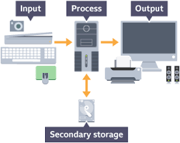

**Hardware:**

* A minimum computer system that will help you access all the tools in the courses is a Pentium 166 or better
* 64 Megabytes of RAM or better

**Software [Either or combination as per course/sem]:**

* + Notepad/HTML editor /CoffeeCup
  + Angular / Angular JS /React / BootStrap
  + Dreamweaver / Figma
  + MS IE / Chrome / Firefox / Netscape /MS Edge

Site Map

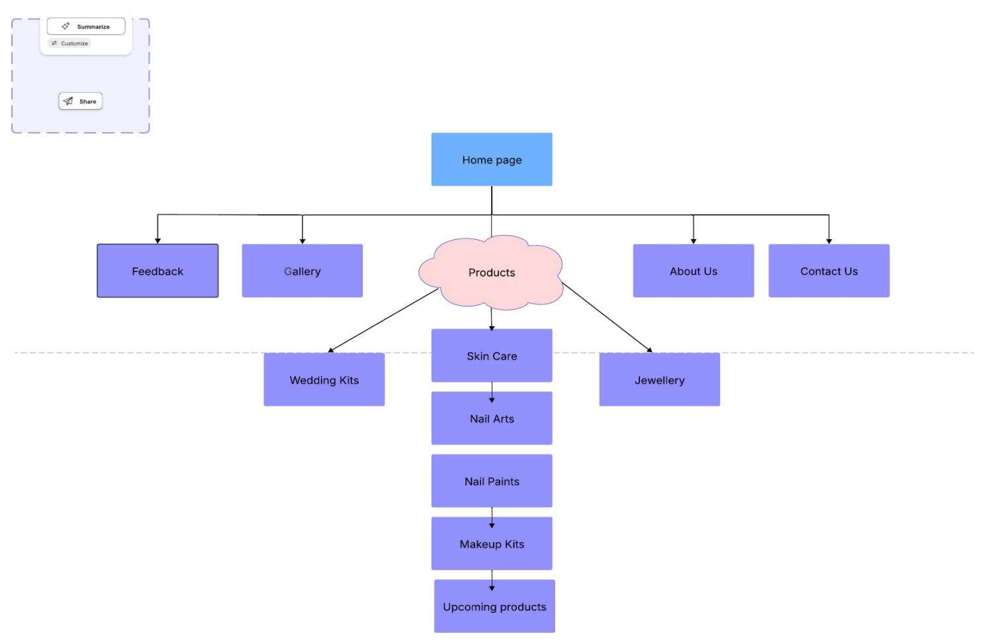

Task Sheet

**Project Ref. No.: eP/Advertisement Portal Management System/01**

**Project Title: SIMPLONS Beauty Care Website**

**Activity Plan Prepared By: Ali Sher**

**Date of Preparation of Activity Plan*:***

| **Sr.No.** | **Task** | **Actual Start Date** | **Actual Days** | **Team Mate Names** | **Status** |
| --- | --- | --- | --- | --- | --- |
| 1 | Navigation & Categories Setup | 25 Jan 2025 | 4 |  | Planned |
| 2 | Home Page Design & Theme | 29 Jan 2025 | 3 |  | Planned |
| 3 | CSS Styling | 01 Feb 2025 | 4 |  | Planned |
| 4 | Content Creation | 05 Feb 2025 | 5 |  | Planned |
| 5 | About Us Page | 10 Feb 2025 | 2 |  | Planned |
| 6 | Services & Products Section | 12 Feb 2025 | 4 |  | Planned |
| 7 | Contact Us & Feedback Page | 16 Feb 2025 | 3 |  | Planned |
| 8 | Testing | 19 Feb 2025 | 2 |  | Planned |
| 9 | Footer Section | 21 Feb 2025 | 2 |  | Planned |
| 10 | Final Review & Adjustments | 23 Feb 2025 | 3 |  | Planned |
| 11 | Documentation | 26 Feb 2025 | 3 |  | Planned |

Home Page Source Code

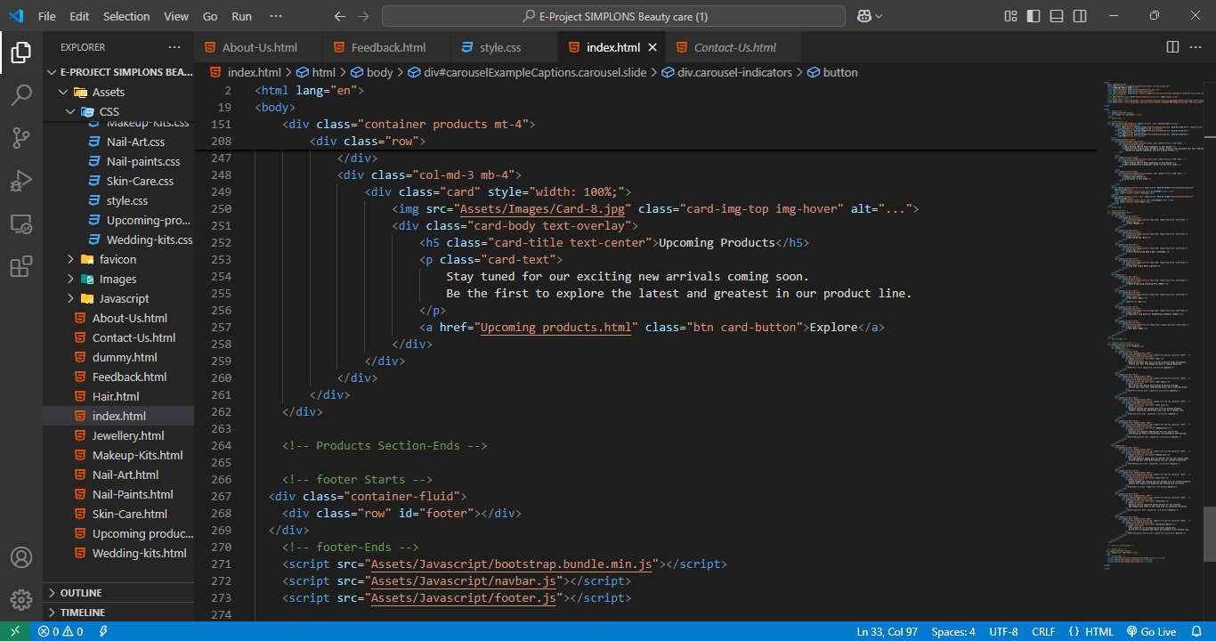

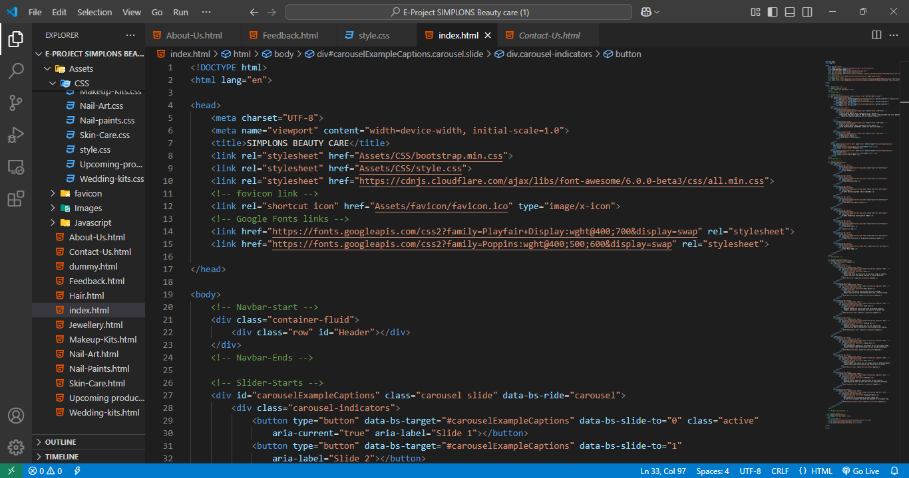

Home Page

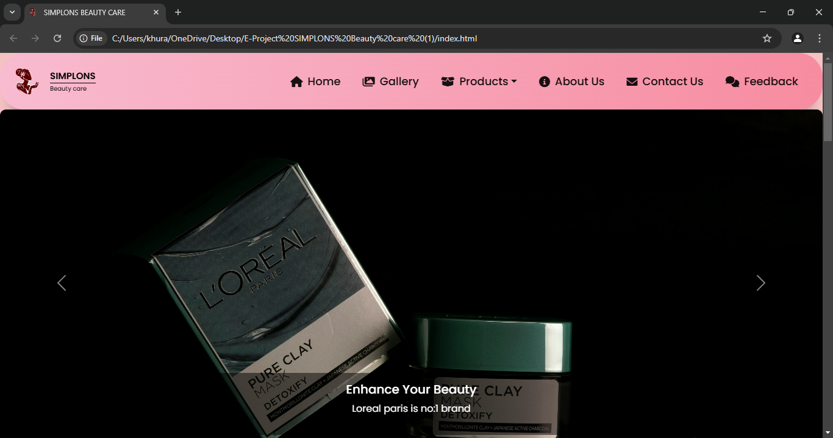

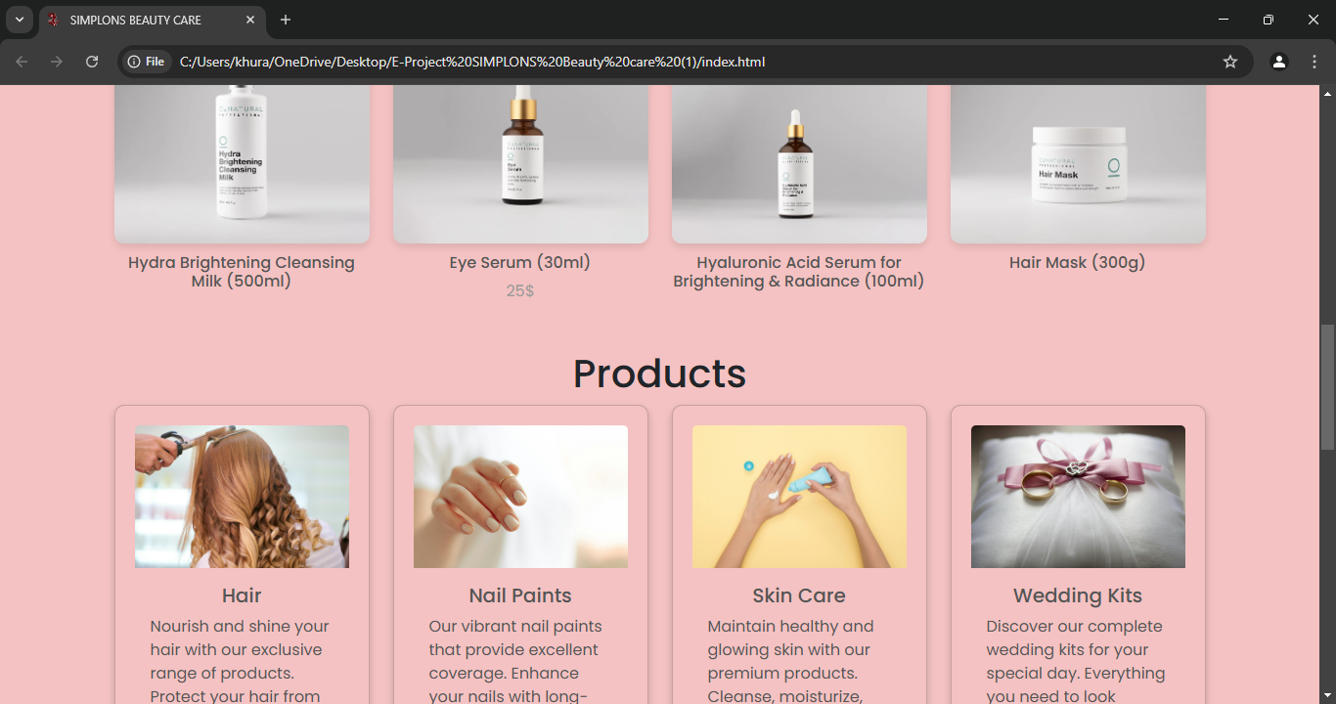

Gallery Source Code

###### 

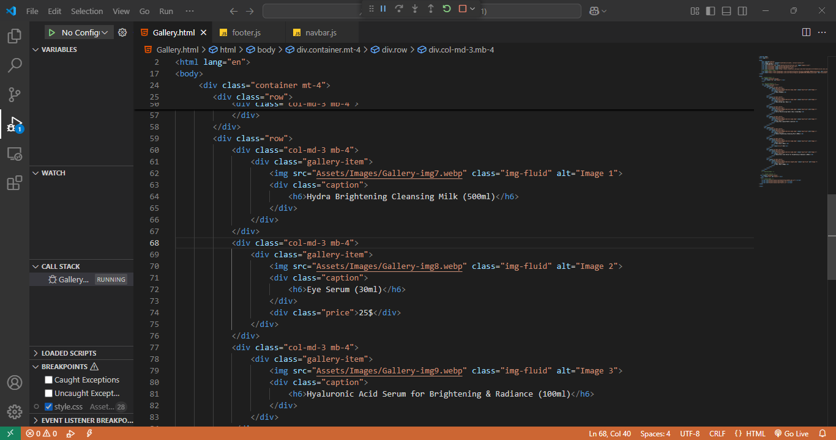

Gallery

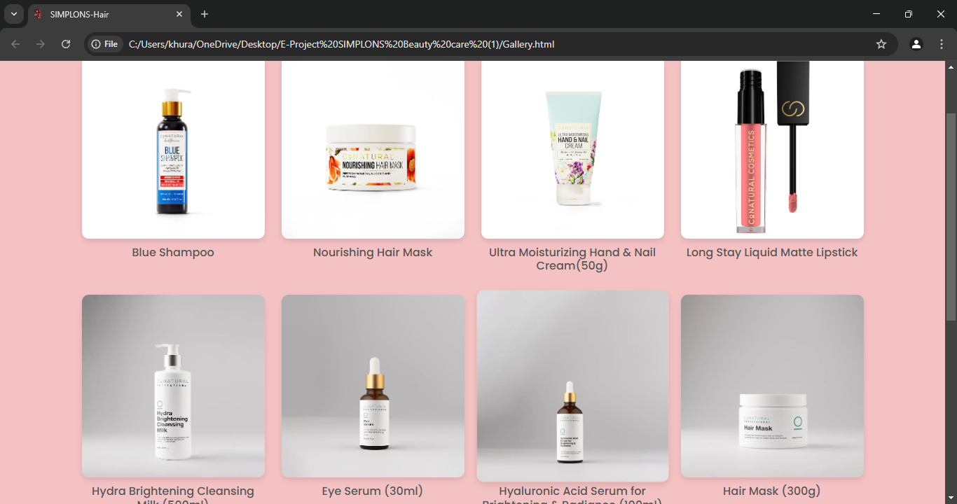

Contact Us Source Code

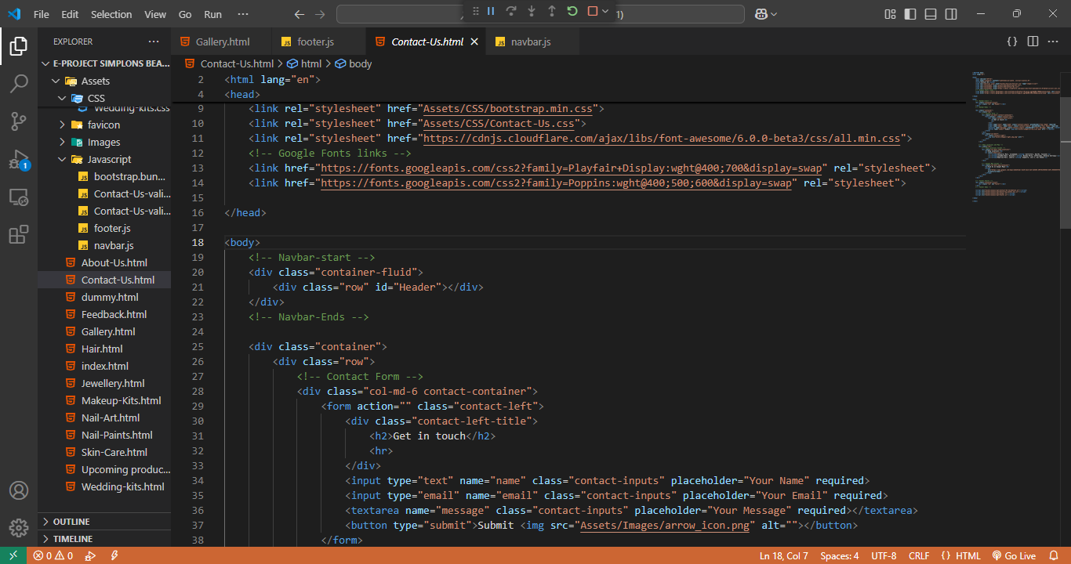

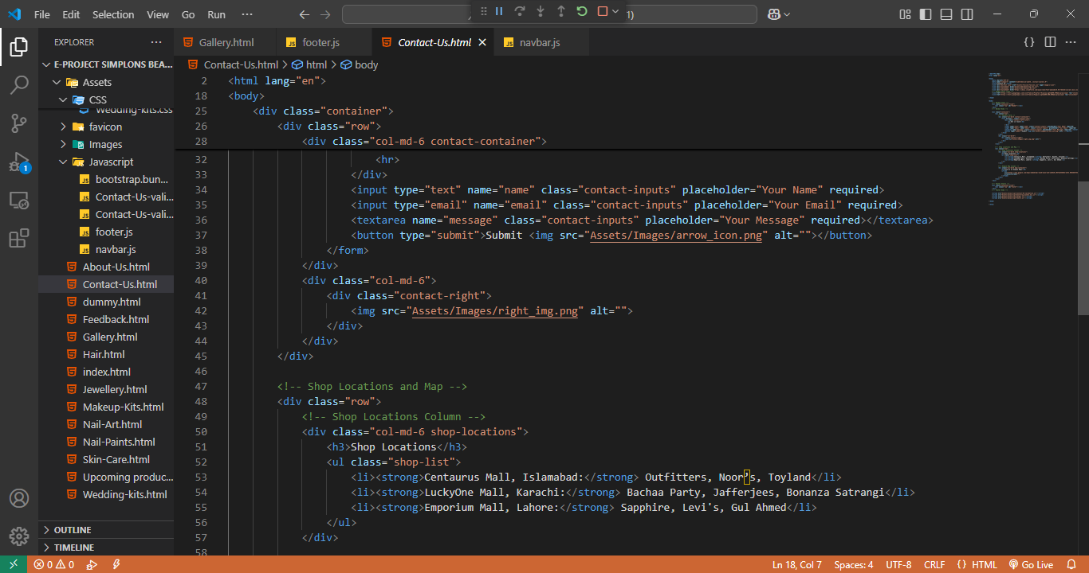

Contact Us

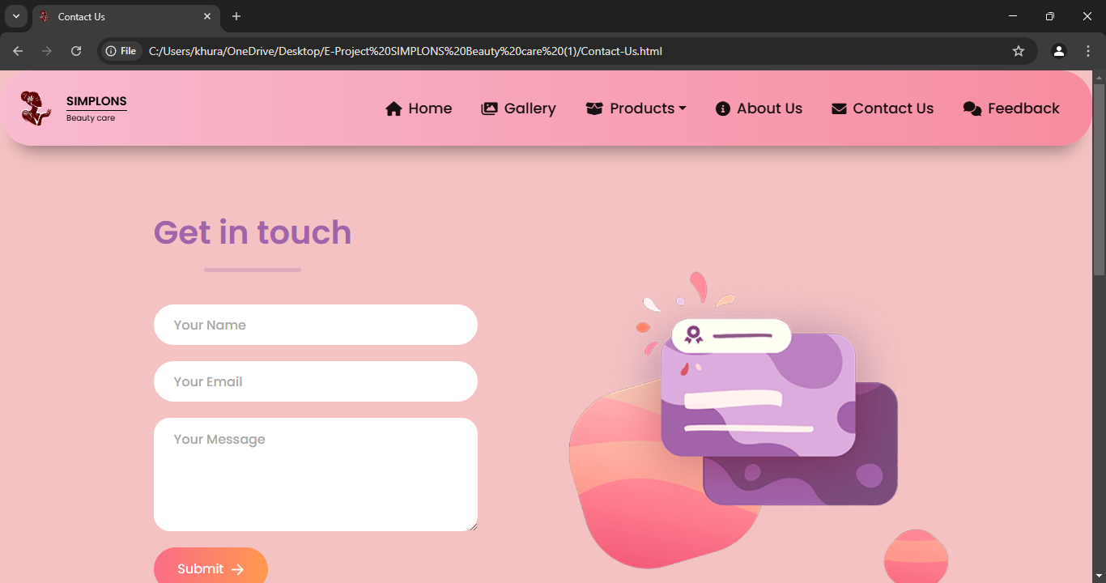

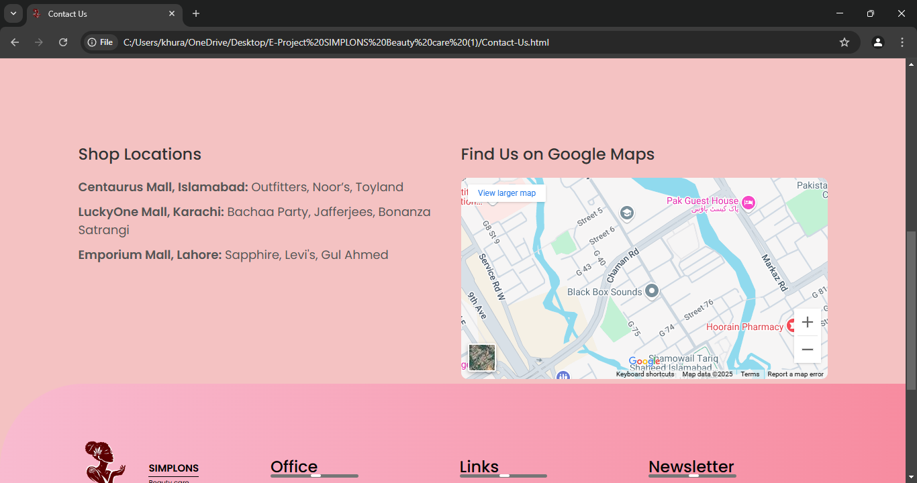

About Us Source code

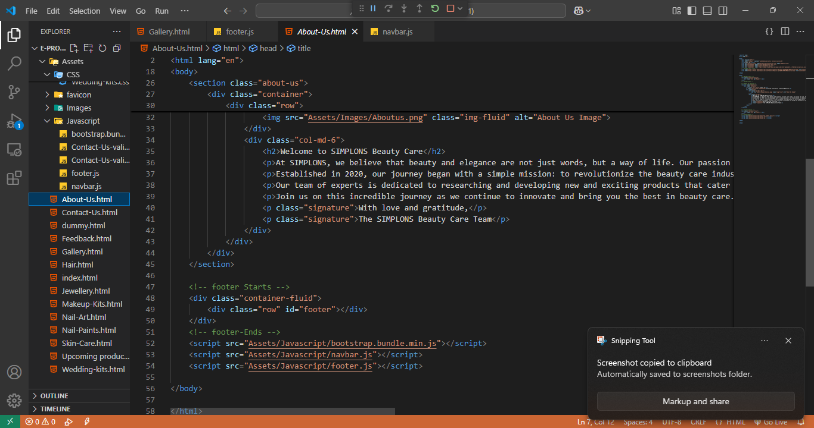

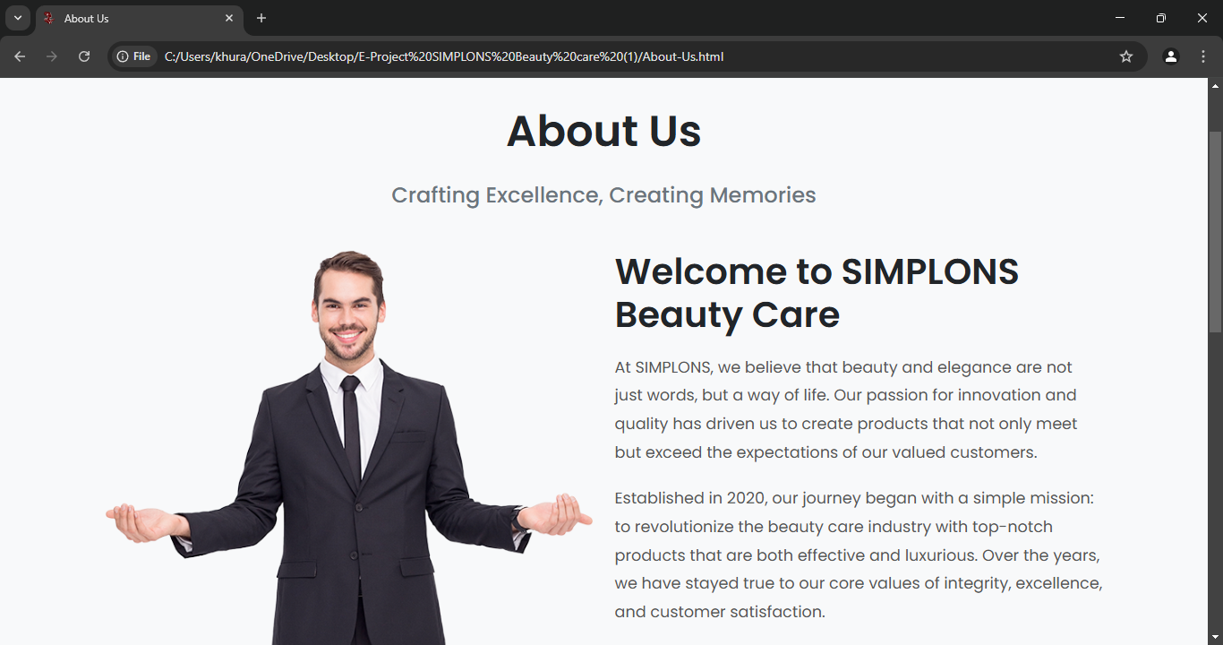

Footer Source Code

###### 

